# **Name: Abdurrahman Qureshi**

# **Roll No: 242466**

Practical No: 10

Q) Write an awk script to print all even numbers in a given range.

CODE:

if [ -z "$1" ] || [ -z "$2" ]; then

  echo "Usage: $0 <start> <end>"

  exit 1

fi

start=$1

end=$2

awk -v start="$start" -v end="$end" 'BEGIN {

  first = 1

  for (i = start; i <= end; i++) {

    if (i % 2 == 0) {

      if (first) {

        printf "%d", i

        first = 0

      } else {

        printf " %d", i

      }

    }

  }

  print ""

}'

OUTPUT:

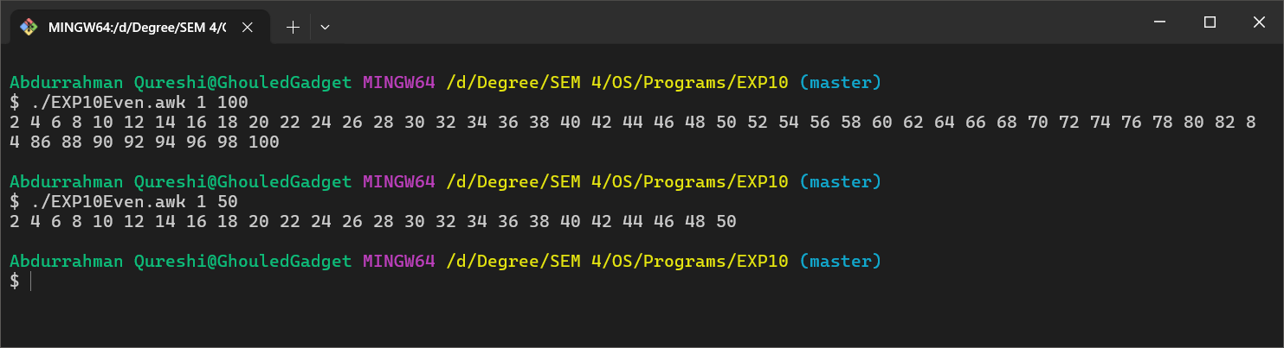

Q) Write an awk script to develop a Fibonacci series (take user input for number of terms).

CODE:

read -p "Enter the number of terms for Fibonacci series: " terms

awk -v terms="$terms" 'BEGIN {

  a = 0

  b = 1

  print "Fibonacci Series:"

  for (i = 1; i <= terms; i++) {

    print "Term [" , i , "] : " , a

    c = a + b

    a = b

    b = c

  }

}'

OUTPUT:

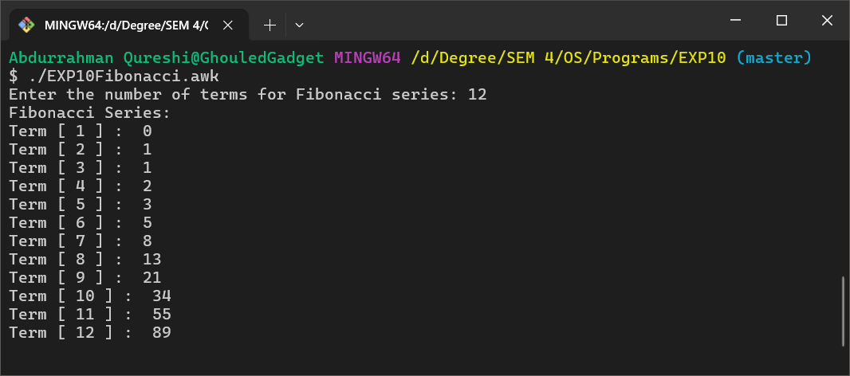

Q) Write a perl script to sort elements of an array.

CODE:

my @array = (5, 3, 8, 1, 9, 2);

my @sorted_array = sort { $a <=> $b } @array;

print "Sorted Array: @sorted_array\n";

OUTPUT:

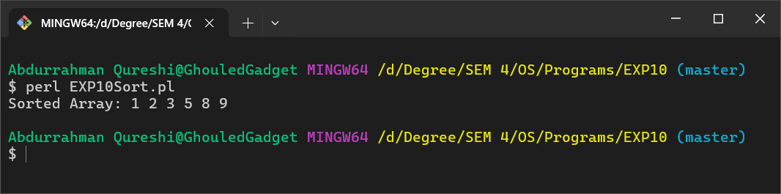

Q) Write a perl script to check a number is prime or not.

**CODE:**

print "Enter a number: ";

my $num = <STDIN>;

chomp($num);

my $is_prime = 1;

if ($num <= 1) {

  $is_prime = 0;

} else {

  for (my $i = 2; $i <= ($num); $i++) {

    if ($num % $i == 0) {

      $is_prime = 0;

      last;

    }

  }

}

if ($is_prime) {

  print "$num is a prime number.\n";

} else {

  print "$num is not a prime number.\n";

}

OUTPUT:

